|  |  |  |  |
| --- | --- | --- | --- |
| **Student’s name** | …………………………………………………….…… | **Grade** | **2** |
| **Subject** | **Computer** | **Week No.** | **3** |
| **Lesson Title** | **Manage Files and Folders** | **Unit** |  |

**Worksheet No. ( 3 )**

**write the correct name of each part**.

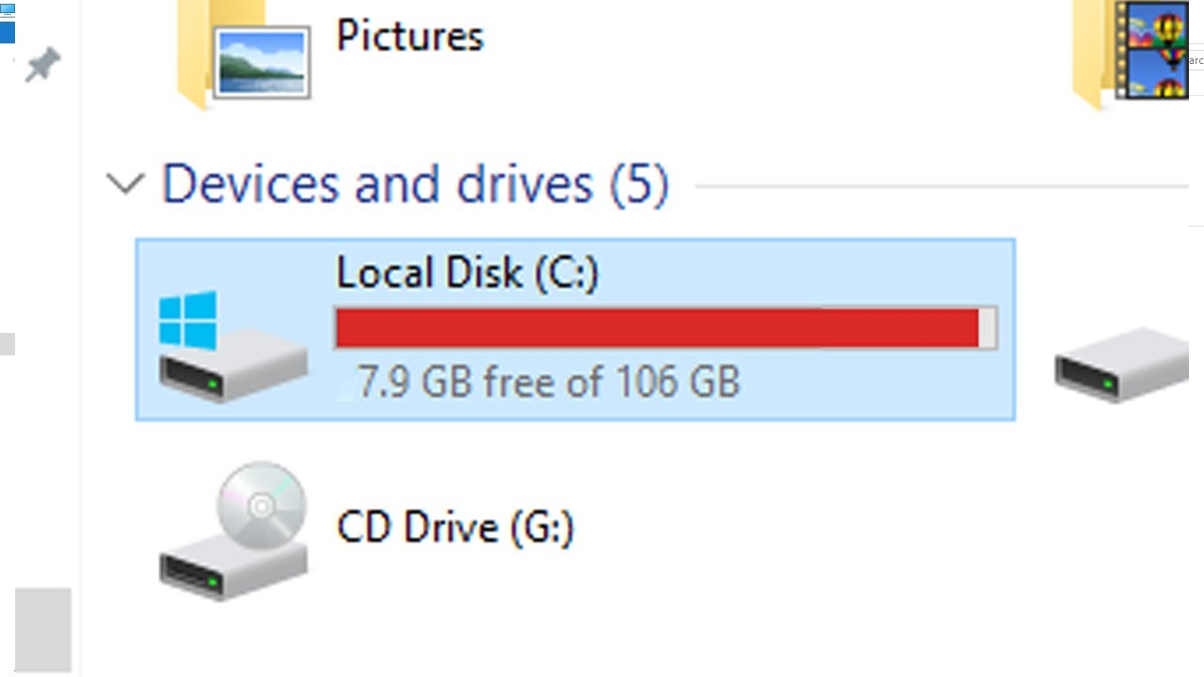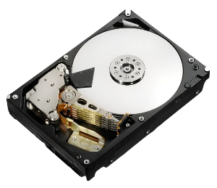

C: Drive

Folder

Hard Disk

**Good Luck**

File